Person tracking robot

# Items

* Nodejs. I will use nodejs combined with the expressjs routing library for the webserver. This is where the program will run on.
* Person pose estimation

To track a persons pose I am going to use a package names posenet that is included in the library ml5js.

<https://ml5js.org/>

* robot tracking

# Concept

The idea is that a robot tracks your movement. With this many possibilities open up. If you want a robot to grab something heavy you can instruct it to do so with your movements. If something delicate needs to be handled in let say a nuclear reactor, you can control the robot from a safe distance.

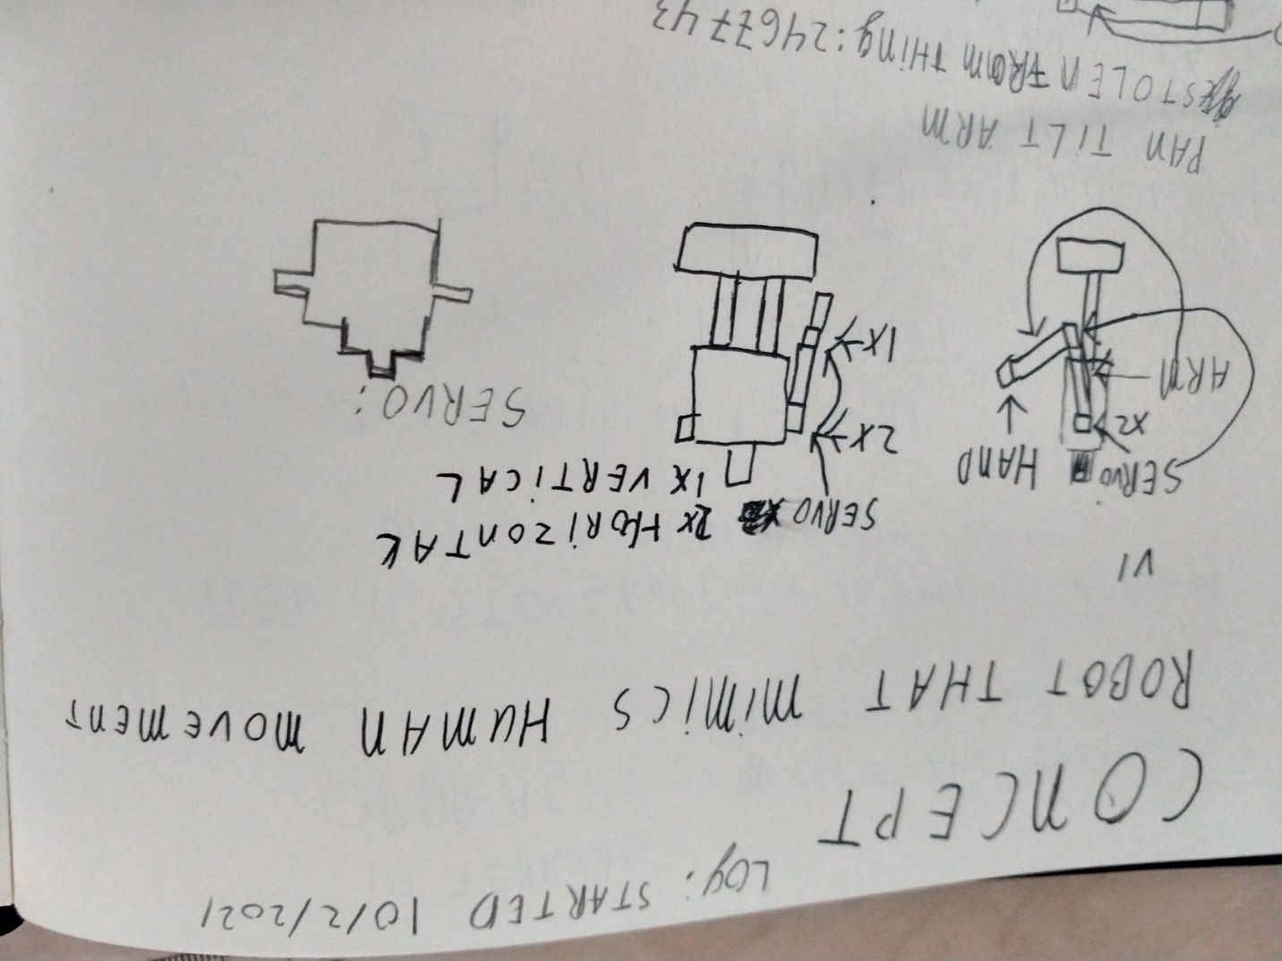

# Goal

For my first POC I am going to track a persons stance with a camera. If the program notices your arm going up, it will mimic the same with the robot. I hope to learn more about object tracking, nodejs and 3d printing.

# Planning

|  |  |
| --- | --- |
| Week 1 | Finished setting up camera with person tracking and simple webserver |
| Week 2 | Start 3d print designing |
| Week 3 | finishing |

# Research

## Questions

### How do I create a robot that will track and mimic my movement(arms)?

### What

##### What am I going to build?

* What will it look like?
* What will be the scale?
* How realistic will it look?
* Where will it be made?

### Why

##### Why am i going to create this?

* What do we benefit from this?

### How

#### What do I need to prepare for this project?

##### How will I calculate the degrees of my servo’s?

* How do I get the current direction of the arm
* How do I determine de current angle of the joints
* How do I determine the depth of the arm.
* How will I work with the false detections/false positives

For this protoype I will use a camera to determine my posture.

##### How will I retrieve the coordinates of the joints on my camera?

* What library will I use
* What language will be used

##### How will the robot be built?

* What components does the robot need?
* How will the components be combined?
* How are the components being controlled?

## Answers

### What am I going to build?

As stated in my intro I am going to build a system that tracks my posture. From this tracking i will be able to pinpoint my joints in my arm. This will be translated for servos that my robot use to mimic me.

#### What will it look like?

#### What will be the scale?

#### How realistic will it look?

#### Where will it be made?

### Why am I going to create this?

## Research

After an global search i came across the tensorflow posenet library. This library tracks my posture and does what i need. I had big problems installing tensorflow and the posenet package. I spoke to a friend who has made an own project with posture tracking. He recommended the ml5js library. This works great!

I used this example to base my nodejs server on.

<https://github.com/ml5js/ml5-library/tree/main/examples/p5js/PoseNet/PoseNet_webcam>

The results are listed in the ml5 example directory.

In the javascript i can retrieve the positions of the keypoints. I need this data to be able to translate the positions to the servo’s. There is one major problem. The data from the client(the webbrowser) needs to be passed to the backend. In this case the nodejs server. This is not ideal. I have an idea how i can use websockets to achieve this but i rather be able to build an program that does not require an webbrowser. I have tried OpenCV, and opensource ai image library, before this project. I could barely get it to start and dont have good memories of it. I went and looked for alternatives.

I found this: <https://github.com/rwightman/posenet-pytorch>

This is a mash of opencv, posenet and pytorch. I am going to give this a try.

Story short, I did not get it to work. I have tried it on windows, Linux wsl and an linux virtualmachine. I noticed the code is pretty outdated. It had not received an update in 2 years and when installing the recommended library it was not available anymore.

With this I realized I need to stop wasting time on something new and start with something I know, javascript. The first step for me is to get the serial communication working on NodeJS. I am using the npm serialport package(<https://duckduckgo.com/?t=ffab&q=nodejs+serial&ia=web> ). This is the only package nodejs as for javascript as the client side is still experimental and unavailable.

The demo code can be found in demo_nodejs_communication.

Now this is working the next step is to get the data the robot needs